## Image

1. Project id: hw2p1-image

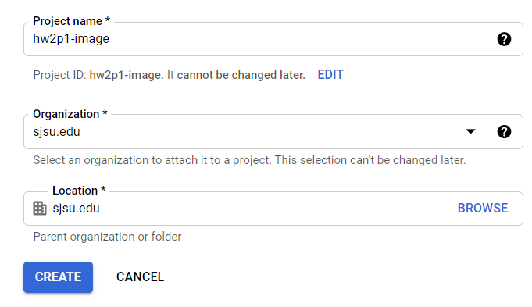

1. API is enabled

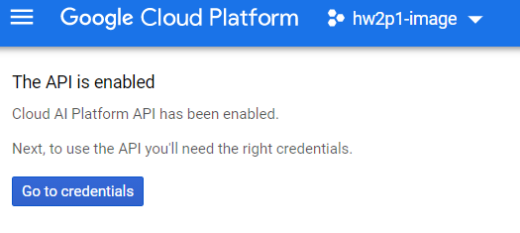

1. Authentication Setup

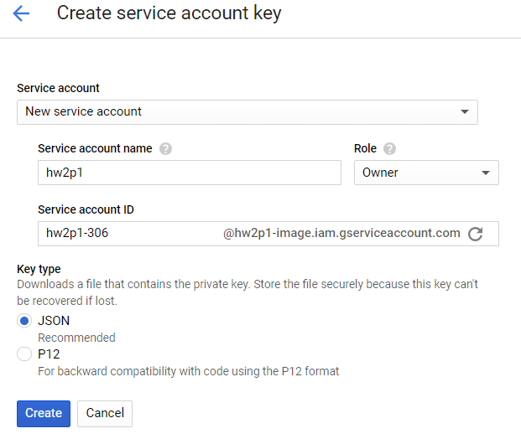

1. Set environment variable

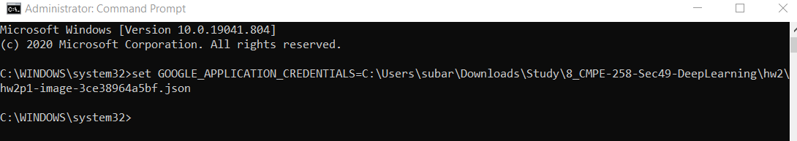

1. Cloud Console:

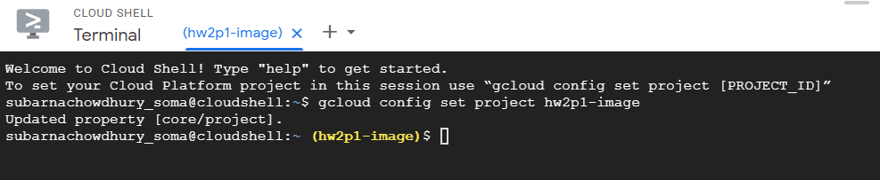

1. Created Google Cloud Storage Bucket

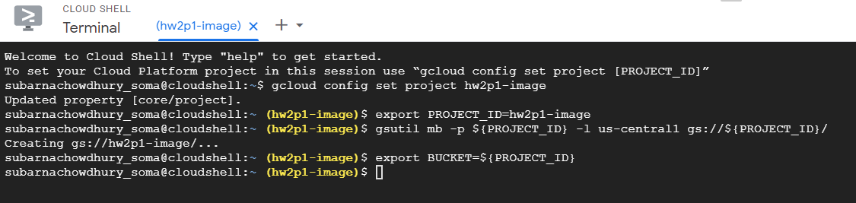

1. Copying data set to storage:

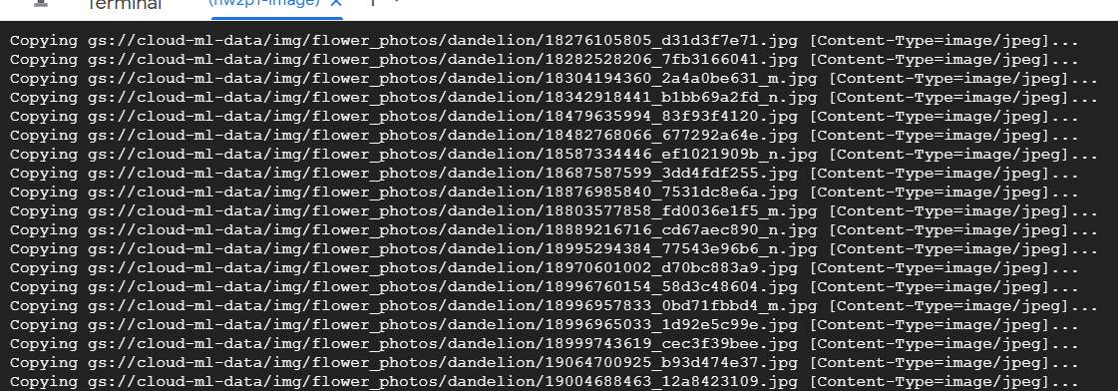

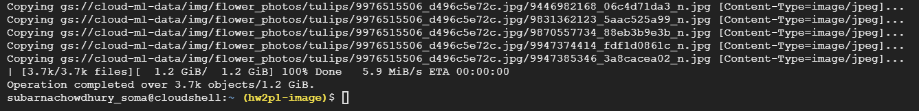

1. Created all_data.csv file with image and labels

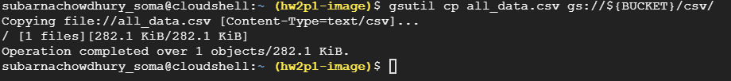

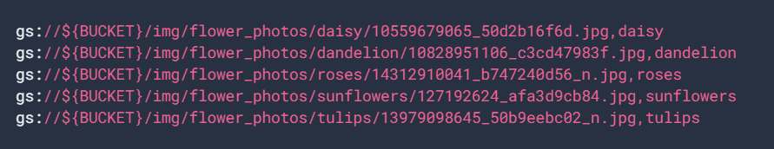

1. Create Dataset ‘hw2p1-imagedata’

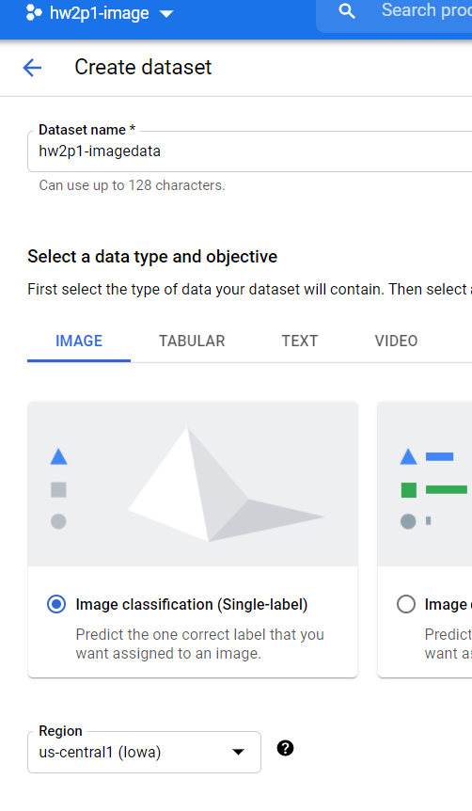

1. Import Data from Storage

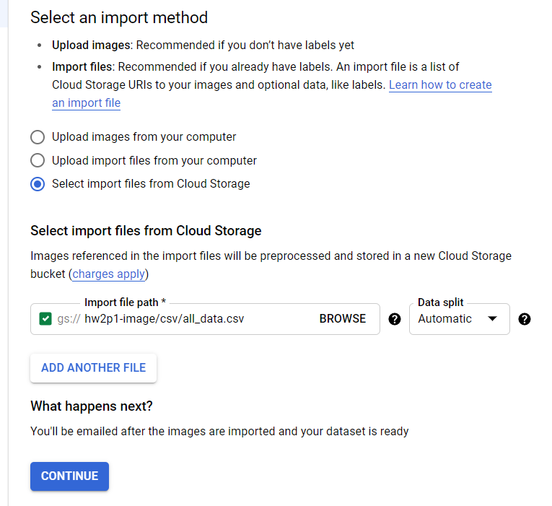

1. Finished Importing Data



1. Selecting Training Model:

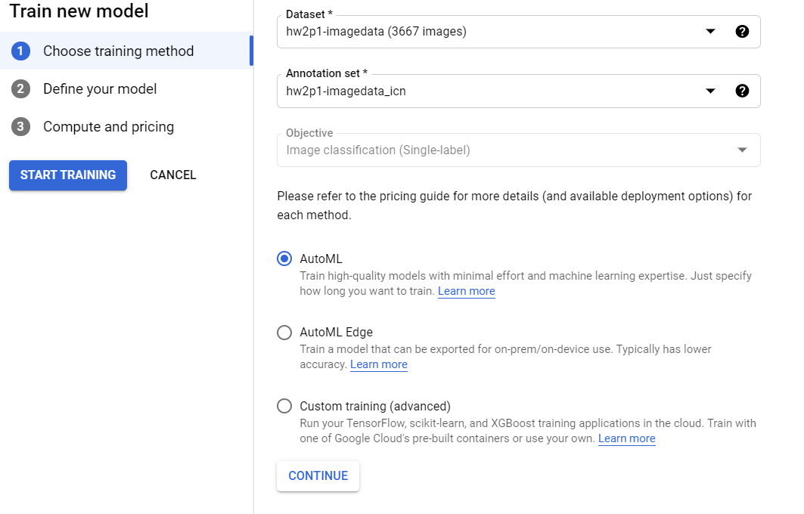

1. Created model ‘hw2p1-imagedata_model’ and selected pricing for 8hours

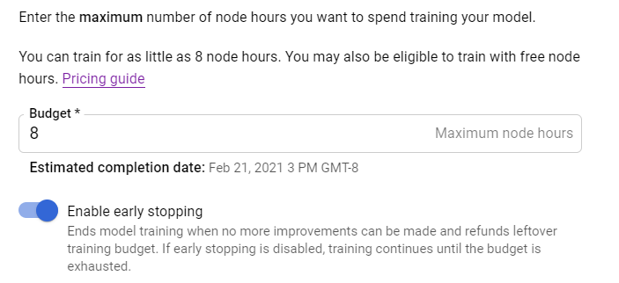

1. Got Email Notification about successful training

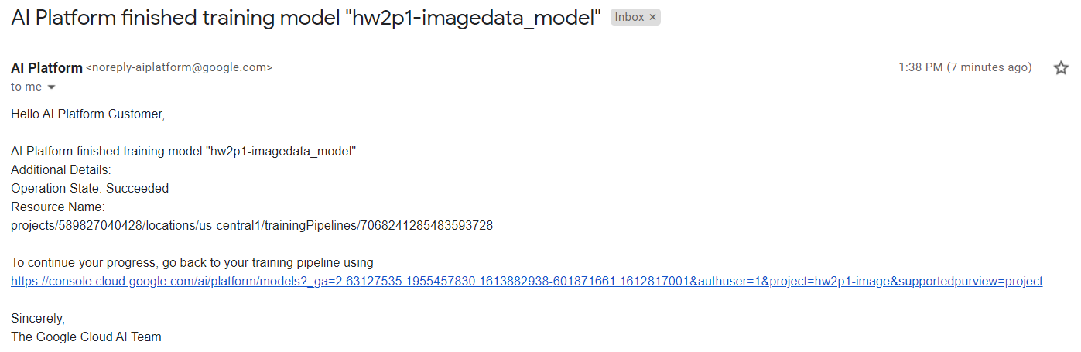

1. Trained Model

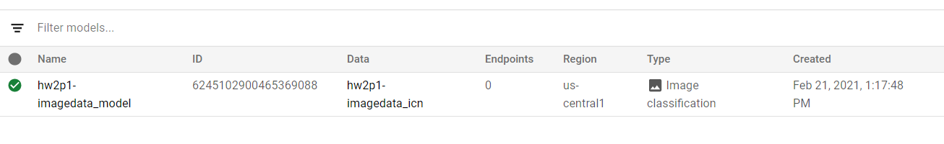

1. Created Deployment Endpoint ‘hw2p2-hello_automl_image’

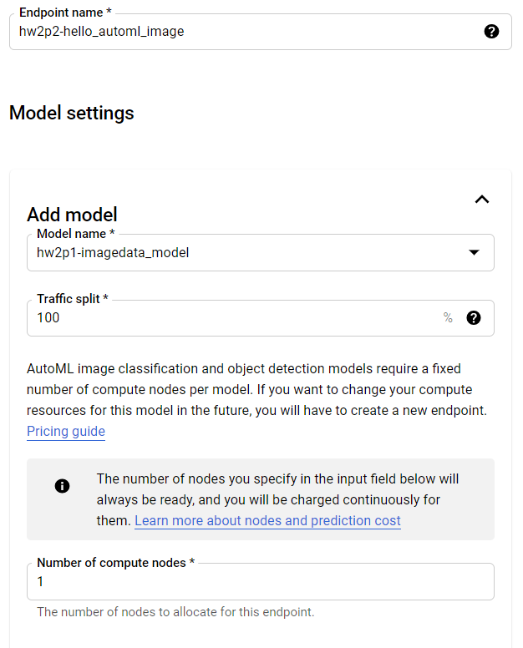

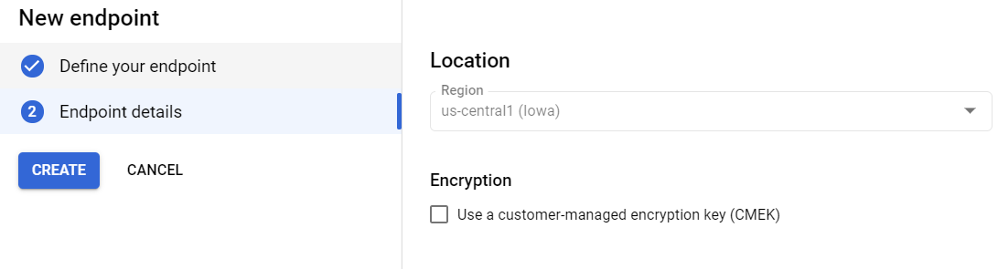

1. Model Deployment

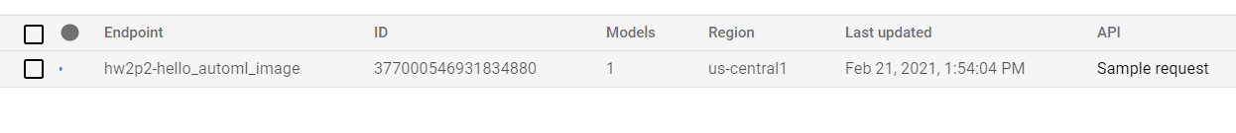

1. Successful Deployment

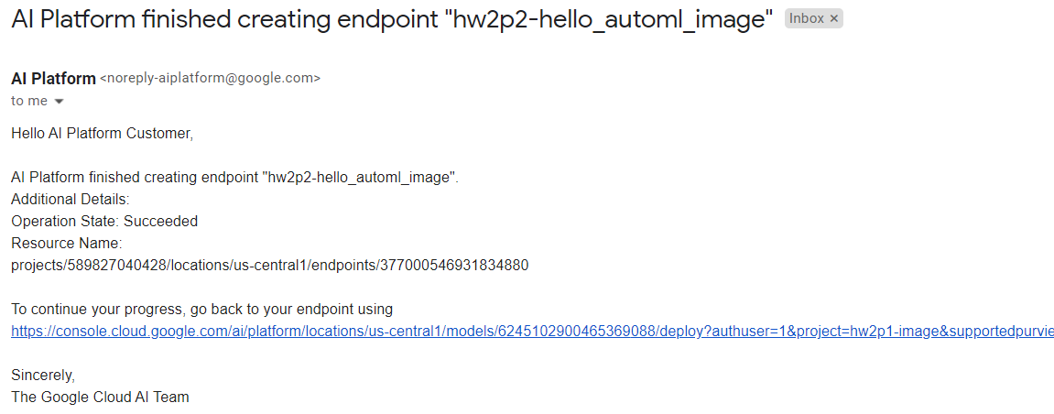

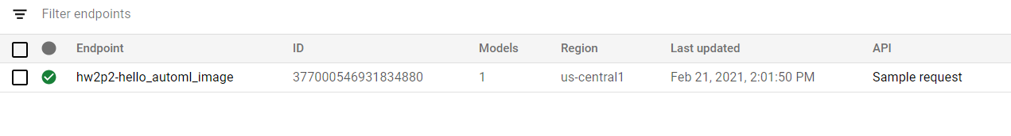

1. After Deployment

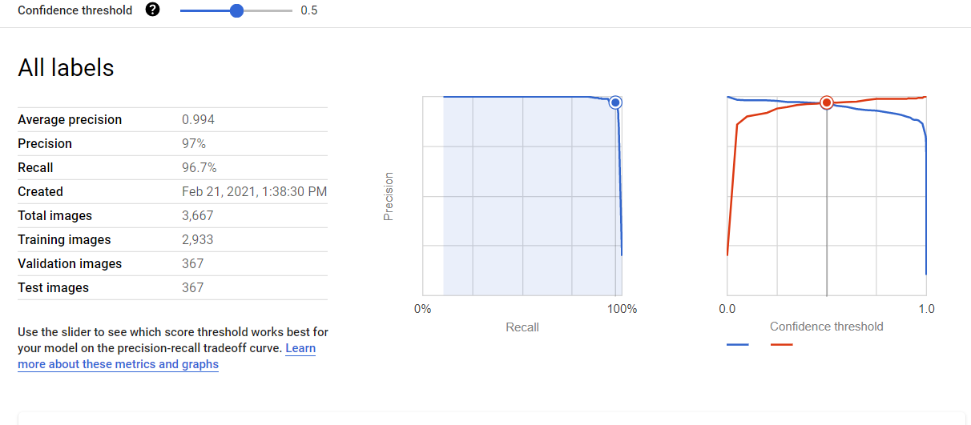

1. Confusion Matrix

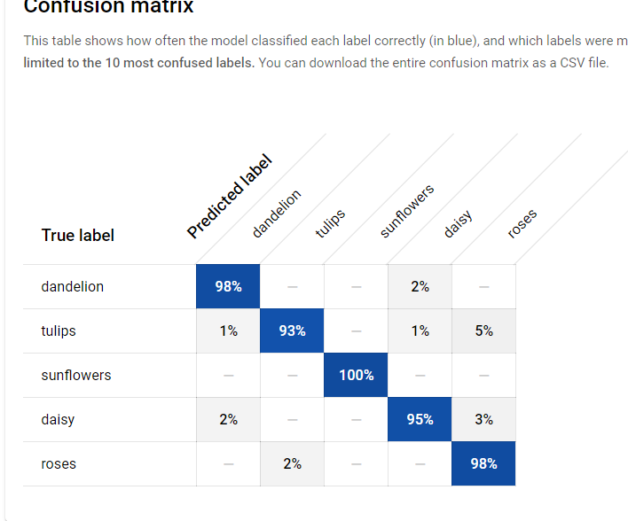

1. Prediction 100% Correct

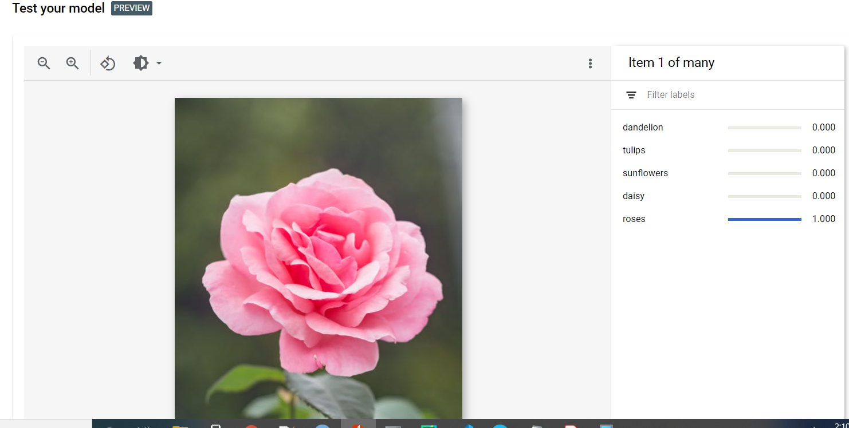

1. Removed Storage

